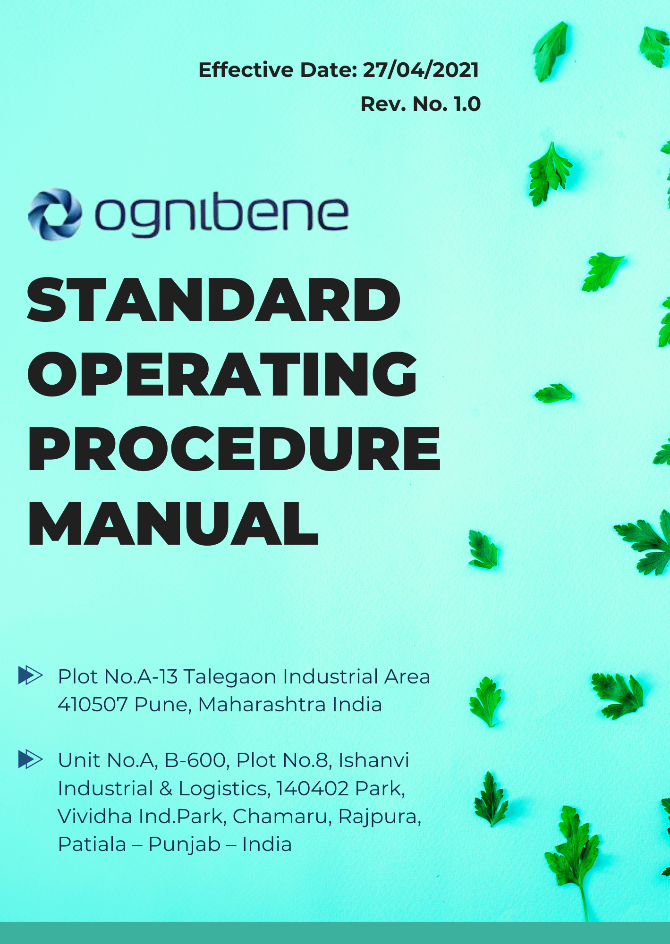

INDEX

STANDARD OPERATING PROCEDURES (SOP) MANUAL 5
⧫ Introduction 5
⧫ Scope 5
SOP ON HAZARDOUS MATERIAL MANAGEMENT AND SUBSTITUTION 6
1. Objective 6
2. Scope 6
3. Responsibilities 6
4. Procedure 7
5. Review and Revision 9
SOP ON WASTE REDUCTION AND MATERIAL OPTIMIZATION 10
1. Objective 10
2. Scope 10
3. Responsibilities 10
4. Procedure 11
5. Review and Revision 14
SOP ON PRODUCT LIFECYCLE MANAGEMENT 15
1. Objective 15
2. Scope & Applicability 15
3. Responsibilities 15
4. Procedure 16
5. Documentation and Communication 18
6. Review and Revision 18
SOP ON SUSTAINABLE PRODUCT DESIGN & MATERIAL STEWARDSHIP 19
1. Objective 19
2. Scope & Applicability 19
3. Responsibilities 19
4. Procedure 20
5. Documentation and Communication 22
6. Review and Revision 22
SOP ON CIRCULAR ECONOMY PRACTICES 23
1. Objective 23
2. Scope & Applicability 23
3. Responsibilities 23
4. Procedure 23
5. Documentation and Communication 25
6. Review and Revision 25
SOP ON ETHICAL BUSINESS CONDUCT & CONFLICT OF INTEREST MANAGEMENT 26
1. Objective 26
2. Scope & Applicability 26
3. Responsibilities 26
4. Procedure 26
5. Documentation and Communication 28
6. Review and Revision 28
SOP ON INFORMATION SECURITY INCIDENT RESPONSE 29
1. Objective 29
2. Scope & Applicability 29
3. Responsibilities 29
4. Procedure 29
5. Documentation and Communication 31
6. Review and Revision 31
SOP ON THIRD-PARTY DATA PROTECTION & CONSENT MANAGEMENT 32
1. Objective 32
2. Scope & Applicability 32
3. Responsibilities 32
4. Procedure 33
5. Documentation and Communication 35
6. Review and Revision 35
PROCEDURE FOR FACTORY NOISE PREVENTION 36
1. Objective: 36
2. Scope & Applicability 36
3. Procedure 36
4. Noise Monitoring Log Template 38
5. Reporting and Record Keeping 38
6. Review and Revision 38
PROCEDURE FOR WATER-BASED PAINT DUST COLLECTION 39
1. Objective: 39
2. Scope & Applicability 39
3. Equipment and Materials Required 39
4. Procedure 40
5. Dust Collection During Operations 40
6. Post-Operation Cleanup 41
7. Maintenance of Dust Collection Systems 42
8. Record Keeping 42
Procedure for ETP & STP Operation 43
1. Objective: 43
2. Scope 43
3. Applicability & Eligibility 43
4. Responsibilities 43
5. Procedure 43
6. Miscellaneous: 45
7. Date of effective: 45
8. Changes or Modification Communication: 45
9. Confidentiality: 46
STANDARD OPERATING PROCEDURES (SOP) MANUAL REVIEW 47

STANDARD OPERATING PROCEDURES (SOP) MANUAL

Introduction
This Standard Operating Procedures (SOP) Manual has been developed to guide and standardize the operations of Ognibene India Pvt. Ltd., a leading manufacturer of hydraulic cylinders and steering units for off-highway vehicles, automotive, and marine applications. The procedures outlined in this manual are designed to ensure consistency, efficiency, and compliance with regulatory requirements across all our operations.

The manual covers essential operational procedures including hazardous material management, waste reduction, product lifecycle management, sustainable design, circular economy practices, ethical business conduct, information security, and data protection. By adhering to these procedures, Ognibene India Pvt. Ltd. seeks to uphold its commitment to operational excellence, regulatory compliance, and sustainable manufacturing practices in the hydraulic systems industry.

Scope
This Standard Operating Procedures (SOP) Manual applies to all personnel associated with Ognibene India Pvt. Ltd. (OIL), including employees, directors, officers, agents, contractors, and third parties acting on behalf of the company. The procedures outlined herein govern all business activities across procurement, sales, marketing, and interactions with government officials, customers, suppliers, and other stakeholders.

This manual is applicable globally, superseding local business practices and cultural norms, and covers operations at the following locations:

Unit 1: | Ognibene India Private Limited – Pune Plant (I)  Plot A-13 Talegaon MIDC Village Ambi Navlakh Umbhre Talegaon, Pune Maharashtra – India
Unit 2: | Ognibene India Pvt. Ltd.  Unit No. A, B-600, Plot No.8, Ishanvi Industrial & Logistics 140402 Park, Vividha Ind.Park, Chamaru, Rajpura Patiala – Punjab – India

SOP ON HAZARDOUS MATERIAL MANAGEMENT AND SUBSTITUTION

Objective
The purpose of this SOP is to guide the implementation of alternative, less hazardous substances in operations and to reduce the generation or toxicity of hazardous substances. The goal is to ensure safe manufacturing processes, reduce environmental pollution, and contribute towards sustainable development by minimizing the usage of Persistent Organic Pollutants (POPs).
Ognibene India Pvt., being a manufacturer of hydraulic cylinders and steering units for off-highway vehicles, automotive, and marine applications, prioritizes the safety, comfort, and performance of its systems. This SOP supports these objectives by enhancing operational safety through the use of less hazardous materials in production processes.

Scope
This SOP applies to all departments involved in the procurement, storage, handling, and disposal of hazardous substances. The focus is on replacing hazardous materials with environmentally friendly alternatives in the following areas:
- Manufacturing operations, especially in the production of steering systems for vehicles, which are critical to safety and performance.
- Painting, coating, and adhesive processes
- Solvent usage and disposal
- Waste management and disposal of hazardous substances.

Responsibilities
- EHS Manager: Responsible for reviewing and updating this SOP periodically, implementing safer alternatives, and ensuring that safety measures are in place for hazardous material handling.
- Procurement Department: Responsible for sourcing and purchasing alternative, less hazardous materials.
- Supervisors: Ensure that staff adhere to safety protocols and that only authorized personnel handle hazardous substances.
- Employees: Comply with the procedures outlined in this SOP for safe handling and usage of alternative and hazardous materials.
- Contractors: Must follow company procedures when dealing with hazardous materials, ensuring that alternatives are utilized wherever applicable.

Procedure
- Substitution of Hazardous Materials with Alternatives
- The company actively seeks to minimize the use of hazardous substances through the adoption of alternative materials that pose less risk to human health and the environment.
  - Replacing hazardous metals with recycled and bio-based materials during the manufacturing process, including the use of recycled steel in the production of hydraulic cylinders and steering units.
  - The transition to eco-friendly paints, adhesives, and coatings, which help to minimize environmental and health hazards.
  - Utilizing bio-based oils and solvents that are derived from renewable resources and are safer than petroleum-based products.
- The Procurement Department will work with vendors to ensure that a portion of all purchased materials are sourced from sustainable or bio-based alternatives within the next operating period.

- Reduction of Hazardous Substance Generation or Toxicity
- The use of specific work processes and techniques to reduce toxicity generation during operations:
  - Paints and Coatings: opt for water-based paints and coatings, which produce less hazardous waste compared to traditional solvent-based paints.
  - Adhesives and Solvents: Shift towards low-VOC adhesives and bio-solvents that significantly lower toxic emissions. The adoption of water-based adhesives has reduced hazardous waste output.
  - Reduction in Solvent Use: The company has implemented closed-loop solvent recycling systems, which have lowered solvent waste considerably.
- Training is provided to all relevant employees on the safe use and disposal of hazardous materials and alternatives, with a goal to steadily reduce hazardous substance generation over time.

- Minimization of Persistent Organic Pollutants (POPs)
- The company is committed to minimizing or eliminating the use of Persistent Organic Pollutants (POPs) in its operations.
  - Polycyclic Aromatic Hydrocarbons (PAHs): Through the adoption of bio-based oils, the company has taken measures to reduce PAH emissions. PAHs commonly arise from fossil fuel-based lubricants used in hydraulic systems and steering units.
  - Pesticides & Industrial Chemicals: Ognibene has eliminated the use of industrial chemicals like PCBs (Polychlorinated Biphenyls) and HCHs (Hexachlorocyclohexane) in its manufacturing process.
  - Waste Management: Incineration of hazardous waste to dispose of POPs (PCDD/Fs and PAHs) is now minimized through the use of advanced filtration and waste-recycling technologies.
- The company has transitioned to using POP-free materials in a large portion of its production processes. An annual audit is conducted to ensure compliance.

- Documentation and Reporting
- The EHS Manager will maintain a record of all alternative materials used in operations, along with their potentially hazardous waste reductions.
- Monthly reports are submitted to the General Manager, detailing:
  - Amounts of hazardous materials substituted
  - Reduction in toxicity generation
  - Reduction in hazardous waste outputs
- The company will also maintain an annual environmental impact report to track progress towards the complete elimination of POPs.

- Waste Disposal
- All waste materials, especially those classified as hazardous, will be disposed of through Certified Hazardous Waste Treatment Disposal Facilities (CHWSTDF).
- Regular audits and inspections are conducted by the EHS team to ensure that no POPs or other hazardous substances are disposed of improperly.

Review and Revision
This SOP will be reviewed annually by the EHS Manager and updated as required to reflect advancements in technology and materials.

SOP ON WASTE REDUCTION AND MATERIAL OPTIMIZATION

Objective
This SOP aims to provide guidance on reducing internal waste through material reuse, recovery, or repurposing, efficient sorting of waste according to waste streams, and mapping of waste streams to improve waste management practices.
Ognibene India Pvt. is committed to minimizing waste generation in its manufacturing processes, particularly in the production of hydraulic cylinders and steering units for off-highway vehicles, automotive, and marine applications. Efficient waste management directly contributes to the company's operational excellence, product quality, and environmental responsibility.

Scope
This SOP applies to all departments involved in the generation, sorting, and disposal of waste materials, focusing on reducing waste through reuse and repurposing. It covers:
- Recovery, reuse, and repurposing of internal materials such as equipment components, scrap metals, furniture parts, etc.
- Sorting waste into different streams for optimized waste handling, recycling, and disposal.
- Mapping of waste streams from their source to final disposal, with a focus on identifying areas for waste reduction and improvement.

Responsibilities
- EHS Manager: Oversees the implementation of waste reduction and sorting processes. Responsible for reviewing and updating waste stream mapping regularly.
- Supervisors: Ensure proper waste handling and sorting is adhered to by all employees in their respective areas.
- Procurement and Maintenance Departments: Identify opportunities for material reuse, recovery, or repurposing within the facility.
- Employees: Responsible for following the waste sorting guidelines and contributing to waste reduction efforts.
- Waste Management Contractors: Must comply with company waste handling guidelines and laws regarding recycling and disposal.

Procedure
- Reduction of Internal Wastes through Material Reuse, Recovery, or Repurpose
- Material Reuse and Recovery:
- The company adopts methods that allow for the reuse and recovery of parts from old equipment, machinery, and furniture. This reduces the need to dispose of these materials as waste.
  - Hydraulic cylinders or steering unit parts that are no longer in working order but are still physically intact are repurposed or repaired for use in new or existing systems. This helps to reduce the generation of scrap metals and other waste components.
  - Furniture Parts and Equipment: Damaged or unused office furniture and electronic equipment are repaired or repurposed rather than discarded. Items that cannot be repaired are sent to appropriate recycling channels.
- Internal Equipment Repurposing:
- Maintenance and Procurement Departments work together to identify components that can be salvaged from old machinery, such as scrap metals, electrical wires, and connectors, to be reused in new assemblies or sold to recycling facilities.
- Damaged parts are often assessed for recovery potential before being classified as waste, and repair initiatives are implemented where possible.

- Internal Sorting and Disposal of Waste According to Waste Streams
- Waste Stream Sorting:
- Waste generated within the facility is sorted into various streams, including:
  - Wood waste: From packaging materials or broken wooden components.
  - Electronic waste (e-waste): Discarded electronic devices such as computers, printers, and control systems.
  - Electrical wires and cables: From old machinery and equipment.
  - Scrap metals: From broken or outdated machinery, vehicle parts, or damaged cylinders and steering components.
  - Glass and Plastics: Generated from broken windows, screens, or plastic packaging materials.
- Sorting bins are clearly labeled and placed throughout the facility to ensure that each type of waste is deposited correctly.
- Appropriate Disposal and Recycling:
- Wood Waste: Sent to recycling centers for repurposing into pallets or other usable materials.
- E-Waste: Disposed of in compliance with electronic recycling regulations.
- Scrap Metals: Collected and sent to metal recycling facilities.
- Plastic and Glass: Segregated for local recycling programs.
- Hazardous Waste: Handled separately and disposed of according to regulations at Certified Hazardous Waste Treatment Disposal Facilities (CHWSTDF).
- Waste Handling Methods:
- Materials that can be reused or repaired are processed internally, while waste that cannot be repurposed is recycled or sent to appropriate waste disposal facilities.
- Regular training sessions are conducted for employees to ensure awareness and adherence to sorting practices and waste reduction efforts.

- Mapping of Waste Streams
- Waste Stream Mapping:
- Waste stream mapping is implemented as a tool to visualize the flow of waste materials from their source (e.g., production lines, maintenance activities) through to recovery, recycling, or disposal.
- The EHS Manager is responsible for mapping all waste streams, including:
  - Sources of waste: Such as production departments or maintenance workshops.
  - Waste types: Classified into categories like wood, e-waste, scrap metals, etc.
  - Recovery methods: Identifying waste that can be reused or repurposed.
  - Final disposal or recycling routes: Highlighting the destination of sorted waste.
- Waste Stream Assessment:
- The waste stream map is regularly reviewed to assess the efficiency of existing waste management practices.
- By mapping the flow of scrap metal waste from hydraulic cylinder production, the company identified inefficiencies in material recovery, leading to changes in how damaged components are stored and processed for recycling.
- Mapping allows for identification of high waste generation areas where further waste reduction measures can be implemented.

Waste Type | Source of Waste | Recovery Methods | Final Disposal/Recycling Routes | Comments/Observations
Scrap Metals | Hydraulic cylinder production | Collected for recycling | Sent to certified metal recycling facility | Inefficiencies identified in storage and recovery methods
Wood | Packaging, carpentry work | Reused for pallets or other wooden products | Recycled or repurposed into wood-based products | Opportunities for improving reuse in production identified
E-Waste | IT equipment, maintenance | Collected for e-waste recycling | Sent to licensed e-waste recycling vendors | Regular audits ensure compliance with e-waste regulations
Plastic | Packaging materials | Segregated for recycling | Sent to plastic recycling facilities | High volumes noted from packaging; reduction measures possible
Oil and Grease | Machinery maintenance | Refined for reuse in industrial applications | Reprocessed or safely disposed via hazardous waste facilities | Proper storage prevents leakage or contamination
Hazardous Waste | Chemical cleaning, solvents | Neutralized or treated before disposal | Handled by licensed hazardous waste disposal companies | Strict monitoring to ensure compliance with regulations
Organic Waste | Cafeteria, food preparation | Composting or biogas generation | Composted or processed for energy recovery | Composting programs implemented to reduce landfill contributions
Wastewater | Industrial cleaning, production processes | Treated on-site or at wastewater plants | Discharged after treatment, or reused in non-potable processes | Regularly assessed for water conservation opportunities
Ash | Combustion by-products | Reused as construction material additives | Landfilled or used in cement production | Minor waste stream; limited recovery opportunities
Paper/Cardboard | Offices, packaging | Recycled | Sent to paper/cardboard recycling plants | Recycling program established to reduce paper usage
Glass | Breakage from production | Collected for recycling | Recycled through glass recovery facilities | Minimizing breakage could further reduce waste generation
Construction Debris | Construction/maintenance activities | Reused where possible, recycled | Disposed of in approved construction waste sites | Regular assessment of materials for potential reuse

Review and Revision
This SOP will be reviewed annually by the EHS Manager and updated as required to reflect advancements in technology and materials.

SOP ON PRODUCT LIFECYCLE MANAGEMENT

Objective
This SOP aims to provide guidance on the efficient use, storage, and maintenance of products to extend their life, as well as information on proper disposal practices that promote circular material flow. This aligns with Ognibene India Pvt.'s commitment to sustainability and responsible environmental practices, particularly in the manufacturing of hydraulic cylinders and steering units.

Scope & Applicability
This SOP applies to all employees involved in the use, storage, maintenance, and disposal of products manufactured by the company. It covers:
- Best practices for extending the useful life of durable goods.
- Guidelines for the proper storage and maintenance of chemical products.
- Information on disposal and recycling options available to product users at the end-of-life stage.

Responsibilities
- EHS Manager: Responsible for developing and distributing information related to product use and disposal practices.
- Supervisors: Ensure that employees are trained on best practices for product use, storage, and maintenance.
- Procurement Department: Communicate the product lifecycle information to customers.
- Employees: Follow guidelines provided to ensure efficient use, maintenance, and proper disposal of products.

Procedure
- Efficient Use, Storage, and Maintenance of Products
- Best Practices for Product Use:
- Users should be provided with information that highlights the best practices for using hydraulic cylinders and steering units efficiently, ensuring optimal performance and longevity.
- Guidelines include:
  - Operating Conditions: Users should operate products within specified limits to prevent excessive wear and tear.
  - Routine Checks: Conduct regular inspections and maintenance as recommended by the manufacturer to detect issues early, with a minimum of monthly checks.
  - Resource Minimization: Users should be informed about techniques to minimize energy or material resources, such as appropriate load management.

- Storage Guidelines for Chemical Products:
- Users should be instructed on how to store chemical products safely to reduce leakage and emissions:
  - Temperature Control: Store products in a climate-controlled environment to prevent degradation.
  - Sealing Containers: Ensure that all containers are tightly sealed to prevent leaks and minimize vapor emissions.
  - Secondary Containment: Use secondary containment systems for bulk storage to capture potential leaks.

- Maintenance Procedures:
- Proper maintenance information should be provided, including:
  - Routine Maintenance Schedule: Outline the maintenance frequency and necessary tasks to keep the product in optimal condition, scheduled at least every 6 months.
  - Repair Protocols: Users should know how to identify issues and perform necessary repairs or contact authorized service personnel.
- Proper Disposal to Promote Circular Material Flow
- End-of-Life Information:
- Users will receive information on how to return, recycle, or dispose of durable products when they reach their end-of-life:
  - Collection Points: Highlight local collection points or programs for returning products for recycling or disposal.
  - Recycling Programs: Provide details on existing recycling programs for components, such as metals and plastics from hydraulic systems.
  - Collection Points & Recycling Programs for Ognibene
• Pune Municipal Corporation Dry Waste Collection Center
    - Address: Near Talegaon MIDC, Pune
Phone: +91 2025501401
    - Services: Collection of dry recyclable waste
• Poornam Ecovision Foundation
    - Address: Survey No 6, Bhukum, Mulshi, Pune, Maharashtra 412115
    - Phone: +91 86009 09852
    - Services: E-waste collection and recycling
• Punjab Pollution Control Board Collection Center
    - Address: Nabha Road, Patiala, Punjab
    - Phone: +91 0175 221 5802
    - Services: Information on local recycling programs and collection points
• Ramky Enviro Engineers Limited
    - Address: Nimbua, Tehsil Dera Bassi, District SAS Nagar, Punjab
    - Phone : +91 40 4442 2222
    - Services: Integrated waste management facility
- Waste Management Infrastructure:
- The company should inform users about available waste management infrastructures, which may include:
  - Partnerships: Collaborations with certified waste management companies that specialize in recycling and environmentally responsible disposal.
  - Local Resources: Information on municipal waste disposal facilities that accept hazardous and non-hazardous waste to promote proper disposal practices.

- Minimizing Environmental Impact:
- Guidelines should stress the importance of minimizing waste to landfill:
  - Separation of Materials: Encourage users to separate materials (e.g., metals, plastics) to facilitate recycling.
  - Avoiding Leakage: Information should be provided to minimize product component or residue leakage into the environment through proper disposal practices.

Documentation and Communication
All relevant documentation regarding best practices, maintenance schedules, and disposal guidelines will be made available to users, including:
- Product user manuals containing safety and maintenance information.
- Disposal guides that detail recycling and disposal options, including any trademarked product names or brand names used in communications.

Review and Revision
This SOP will be reviewed annually by the EHS Manager to incorporate any new best practices or regulatory changes.

SOP ON SUSTAINABLE PRODUCT DESIGN & MATERIAL STEWARDSHIP

Objective
This SOP aims to outline the procedures for eliminating or minimizing substances of concern in electrical and electronic products, as well as establishing programs for labeling, sorting, and recovering electrical and electronic components. This aligns with Ognibene India Pvt.'s commitment to sustainable product development and waste management practices in the production of hydraulic cylinders and steering units.

Scope & Applicability
This SOP applies to all employees involved in the design, manufacturing, labeling, sorting, and recycling processes of electrical and electronic components used in Ognibene India Pvt.’s products. It covers:
- Methods and technologies for reducing or eliminating substances of concern in electrical and electronic equipment.
- Programs and procedures for labeling, sorting, and recovering electrical and electronic components for recycling or disposal.

Responsibilities
- EHS Manager: Responsible for implementing methods to minimize substances of concern and developing recovery programs for electronic components.
- Product Design Team: Ensure that electrical and electronic components comply with elimination or reduction targets for hazardous substances.
- Supervisors: Oversee the proper labeling and sorting of components for recovery and disposal.
- Employees: Follow guidelines for handling, labeling, and sorting components for proper recovery and disposal.

Procedure
- Elimination or Reduction of Substances of Concern in Electrical and Electronic Equipment
- Identification of Hazardous Substances:
- We actively identify and catalog all substances of concern in electrical and electronic components. Our targeted substances include:
  - Lead, mercury, cadmium, hexavalent chromium
  - Polybrominated biphenyls (PBB), polybrominated diphenyl ethers (PBDE)
  - Bis(2-ethylhexyl) phthalate (DEHP), butyl benzyl phthalate (BBP)
  - Dibutyl phthalate (DBP), diisobutyl phthalate (DIBP)
  - Brominated flame retardants, antimony trioxide, halogenated flame retardants
  - Zinc, yttrium, beryllium, nickel, tin
  - Polyvinyl chloride (PVC)

- Substitution of Safer Alternatives:
- We have made significant strides in substituting hazardous substances with safer alternatives. Our practices include:
  - Replacing lead with tin-copper alloys in soldering processes.
  - Substituting brominated flame retardants with halogen-free alternatives.
  - Eliminating phthalates in plastic components, opting for bio-based or non-toxic plasticizers.

- Adoption of Cleaner Technologies:
- Our manufacturing technologies minimize the use of substances of concern. For example:
  - Implementing low-temperature soldering techniques to reduce the use of lead.
  - Using eco-friendly coatings and alternatives for PCB protection to avoid brominated compounds.
  - Incorporating recycled and recyclable materials into electronic components to limit hazardous inputs.

- Programs to Label, Sort, and Recover Electrical and Electronic Components
- Labeling Electrical and Electronic Components:
- All electrical and electronic components manufactured by the company must be clearly labeled to facilitate their sorting and recovery. Labeling practices include:
  - Clear identification of components containing recyclable or hazardous materials.
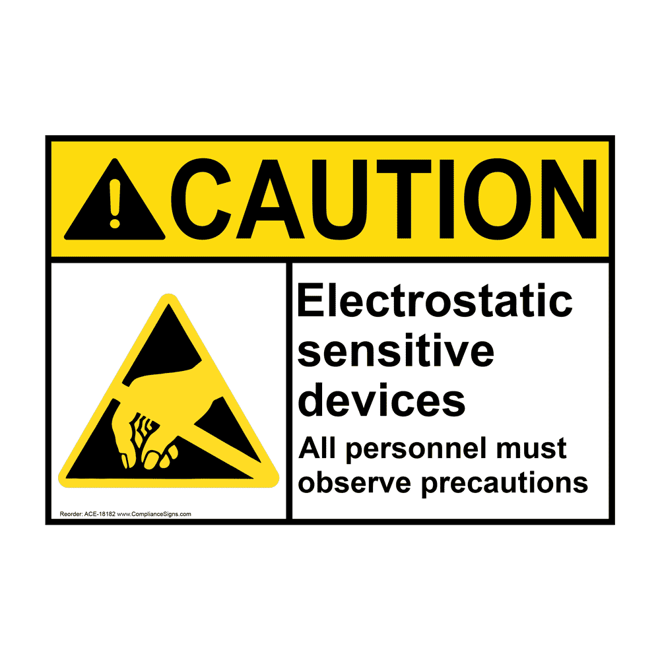
  - Labels that provide information on the material composition of key elements, such as the presence of lead, mercury, or brominated flame retardants.
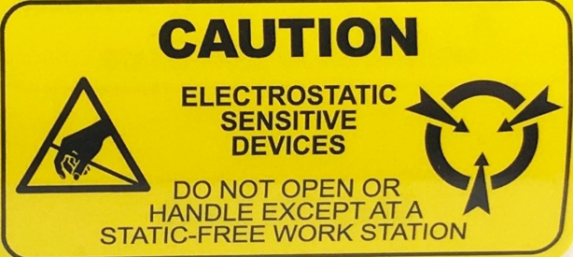
  - Use of internationally recognized recycling symbols and hazard labels.

- Sorting and Recovery of Electrical Components:
- We have implemented robust systems for sorting electrical and electronic components based on their material composition. This allows for proper collection, treatment, recycling, and recovery.
  - Sorting Categories: Components are sorted into categories such as:
    - Hazardous electrical waste (components containing lead, mercury, etc.).
    - Non-hazardous recyclable components (such as metals, plastics).
    - Specialized components (PCBs, batteries).
  - Waste Streams: We create dedicated waste streams for each category to facilitate recycling and recovery, with clear instructions for disposal.
    - Metals and other valuable materials will be sent for recycling to certified facilities.
    - Hazardous components will be handled by certified e-waste management companies.
  - Approved Recycling & Recovery Partners:
  - Poornam Ecovision Foundation
    - Address: Survey No 6, Bhukum, Mulshi, Pune, Maharashtra 412115
    - Phone: +91 86009 09852
    - Services: E-waste collection and recycling

  - Ramky Enviro Engineers Limited
    - Address: Nimbua, Tehsil Dera Bassi, District SAS Nagar, Punjab
    - Phone: +91 40 4442 2222
    - Services: Integrated waste management for electrical and hazardous waste

- Monitoring and Documentation:
- We document all recovered components to track the volume and type of materials recycled or safely disposed of. Monthly reports are generated to monitor our progress in waste recovery programs and material sorting improvements.

Documentation and Communication
- We ensure that all relevant documentation regarding hazardous substance reduction, labeling protocols, and waste recovery practices is accessible to all personnel, including:
  - Product design documents that detail material composition and compliance with hazardous substance elimination targets.
  - Labeling guidelines that outline proper component marking for recovery purposes.
  - Waste recovery records that track the amount and type of materials collected for recycling and disposal.

Review and Revision
This SOP will be reviewed annually by the EHS Manager to incorporate any updates in hazardous substance regulations, new technology for substance elimination, or improvements in waste recovery practices.

SOP ON CIRCULAR ECONOMY PRACTICES

Objective
This SOP provides guidelines on designing products for easy disassembly, remanufacturing, or recycling and details the company's take-back or buy-back programs to collect products for remanufacture, recycling, or safe disposal. Ognibene India Pvt. Ltd. is committed to sustainability by ensuring product components remain in circulation, avoiding landfills or incineration.

Scope & Applicability
This SOP applies to all products manufactured by Ognibene India Pvt. Ltd. and includes:
- Design strategies for easy disassembly and recycling.
- Procedures for the take-back or buy-back of used products from customers for remanufacture or recycling.

Responsibilities
- Product Design Team: Responsible for incorporating design features that allow easy disassembly, sorting, and recycling of product components.
- Operations Team: Implements the remanufacturing and recycling processes.
- Logistics Team: Coordinates the take-back or buy-back programs.
- Customers: Encouraged to return used products through designated locations.

Procedure
- Design for Easy Disassembly, Remanufacturing, or Recycling
- Adoption of Modular Design: Products are designed to facilitate easy disassembly, allowing individual components to be replaced, repaired, or recycled without damaging the entire product.
  - Ognibene's hydraulic cylinders and steering units are designed with standardized parts, eliminating the use of proprietary components where possible, to ensure compatibility with different systems and promote recycling.
- Minimization of Fasteners and Adhesives: Wherever feasible, the design avoids excessive use of screws, glue, or pivots, making it easier to disassemble products at the end of their life cycle.
- Elimination of Hazardous Materials: The design avoids using materials of concern such as lead, mercury, and hexavalent chromium in electrical and electronic products, further promoting safety during disassembly and recycling.

- Take-Back or Buy-Back Program
- Take-Back/Buy-Back Program Implementation: Ognibene India Pvt. Ltd. has established a system where customers can return or sell used products to the company. This helps in recycling or remanufacturing the used product, further extending its life cycle or safely disposing of its components.
- Take-Back or Buy-Back Program Locations: Customers can return used products at the following locations:
1. Ognibene India Private Limited – Pune Plant (I)
- Address: Plot A-13, Talegaon MIDC, Village Ambi, Navlakh Umbhre, Talegaon, Pune, Maharashtra – India
- Tel.: +91 02114 660300
- E-mail: infoindia@ognibene.com
- Services Available:
- Collection of used hydraulic cylinders and steering units.
- Free return of products for remanufacturing or recycling.
- Buy-back program for eligible used products.
2. Ognibene India Pvt. Ltd. – Punjab Unit
- Address: Unit No.A, B-600, Plot No.8, Ishanvi Industrial & Logistics Park, Vividha Industrial Park, Chamaru, Rajpura, Patiala – Punjab, India
- Tel.: +91 0175 221 5802
- E-mail: infoindia@ognibene.com
- Services Available:
- Take-back facility for product returns from Northern India.
- Sorting and recycling of electronic and mechanical components.
- Buy-back program for eligible used products.

- Return Process
- Free Return Shipping: Customers can contact the take-back locations for guidance on shipping large products back to Ognibene India Pvt. Ltd. for recycling or remanufacture.
- Recycling and Safe Disposal: Products returned through the take-back program are either remanufactured into new products or their components are recycled or safely disposed of.

- Minimizing Environmental Impact
- Circular Material Flow: The company’s recycling and remanufacturing processes aim to reduce waste, minimize the extraction of virgin materials, and ensure that as many product components as possible are kept in circulation.

Documentation and Communication
- All product user manuals will include detailed instructions on the take-back or buy-back programs, disassembly procedures, and recycling options.

Review and Revision
- This SOP is reviewed annually by the EHS Manager and the Product Design Team to incorporate advancements in design technology and optimize the take-back and buy-back programs.

SOP ON ETHICAL BUSINESS CONDUCT & CONFLICT OF INTEREST MANAGEMENT

Objective
This SOP outlines our established procedures for reporting and obtaining approval for sensitive transactions, such as gifts and travel. By implementing these procedures, Ognibene India Pvt. Ltd. ensures transparency and integrity in our interactions with external stakeholders, minimizing any potential perception of favoritism.

Scope & Applicability
This SOP applies to all employees, contractors, and representatives of Ognibene India Pvt. Ltd. involved in transactions that may be perceived as sensitive or could imply favoritism. This includes:
- Gifts and hospitality extended to or received from external stakeholders.
- Travel arrangements funded by or involving external parties.

Responsibilities
- EHS Manager: Oversees the implementation of this SOP and ensures that all employees are trained on the approval procedures for sensitive transactions.
- Department Supervisors: Ensure compliance with this SOP within their teams and provide guidance on reporting sensitive transactions.
- Employees: Follow established procedures for reporting and obtaining approvals for sensitive transactions, ensuring transparency and adherence to company policy.

Procedure
- Reporting Sensitive Transactions
- Definition of Sensitive Transactions: Employees are required to report any transactions that involve gifts, travel, or other engagements with external stakeholders that could be perceived as favors. Sensitive transactions may include:
  - Gifts valued over a defined threshold (e.g., INR 5,000).
  - All travel arrangements funded by external parties.
  - Any hospitality exceeding standard business practices (e.g., extravagant meals, entertainment).
- Reporting Process: Employees must complete a Sensitive Transaction Report Form prior to engaging in any sensitive transaction. The form includes:
  - Details of the transaction (date, value, purpose).
  - Identification of external stakeholders involved.
  - A description of the item or service received or provided.
  - Any prior engagements with the external stakeholder that may influence the transaction.
- Obtaining Approval
- Approval Process:
- Once the Sensitive Transaction Report Form is completed, it must be submitted to the employee's immediate supervisor for review.
- The supervisor will assess the transaction and determine if further approval is required based on the nature of the transaction.
- If required, the report will be forwarded to the EHS Manager or designated compliance officer for final approval.

- Criteria for Approval:
- The approval will consider factors such as:
  - The value of the gift or hospitality.
  - The nature and frequency of the transactions with the external stakeholder.
  - The potential for the transaction to create a conflict of interest or the appearance of favoritism.
- Record Keeping: All approved Sensitive Transaction Report Forms will be retained in the department’s compliance records for a minimum of three years. This ensures accountability and transparency in our dealings with external stakeholders.

- Training and Awareness
- Training Sessions: The EHS Manager will organize annual training sessions to educate employees about the importance of complying with this SOP, highlighting examples of sensitive transactions and the appropriate reporting and approval processes.

Documentation and Communication
We ensure that all relevant documentation regarding sensitive transactions, including report forms and approval records, is accessible to all employees. Communication channels will be established to clarify any questions regarding sensitive transactions and their approval processes.

Review and Revision
This SOP is reviewed annually by the EHS Manager to ensure it remains compliant with any regulatory updates and aligns with best practices in ethical business conduct.

SOP ON INFORMATION SECURITY INCIDENT RESPONSE

Objective
This SOP outlines our proactive Incident Response Procedure (IRP) to detect, respond to, and manage breaches of confidential information. By implementing these procedures, Ognibene India Pvt. Ltd. aims to minimize the impact of information security breaches, ensure swift recovery, and reassure affected parties.

Scope & Applicability
This SOP applies to all employees, contractors, and third-party service providers of Ognibene India Pvt. Ltd. who handle confidential information. It encompasses:
- Procedures for detecting breaches of confidential information.
- Guidelines for responding to incidents to mitigate risks.
- Communication protocols for informing affected parties.

Responsibilities
- EHS Manager: Oversees the implementation of the IRP and ensures proper training for all employees on incident detection and response.
- IT Security Team: Monitors systems for potential breaches and leads the response efforts in case of an incident.
- Employees: Responsible for reporting suspected breaches immediately and following the established protocols for incident response.

Procedure
- Detection of Breaches
- Monitoring Systems: The IT Security Team continuously monitors network activity and data access logs to identify any unusual behavior or unauthorized access that may indicate a breach of confidential information.
- Incident Reporting: Employees must report any suspected breaches of confidential information to the IT Security Team immediately, using the Confidential Information Breach Report Form. Key details to include:
  - Description of the incident.
  - Date and time of detection.
  - Nature of the confidential information involved.
  - Any potential sources of the breach.

- Responding to Breaches
- Initial Assessment: Upon receiving a breach report, the IT Security Team will conduct an initial assessment within 4 hours to determine the severity and scope of the breach. This includes:
  - Identifying the type of information compromised.
  - Assessing the number of records affected.
  - Determining the potential impact on the organization and affected parties.

- Containment: If a breach is confirmed, immediate containment actions are initiated to limit further unauthorized access within 2 hours. This may involve:
  - Isolating affected systems from the network.
  - Revoking access permissions for involved accounts.
  - Implementing additional security measures to prevent further breaches.

- Investigation: A thorough investigation will be completed within 24 hours of confirming the breach, including:
  - Analyzing logs and access records.
  - Interviewing employees and stakeholders involved.
  - Identifying vulnerabilities that led to the breach.

- Mitigation: Following the investigation, the IT Security Team will implement corrective actions to mitigate future risks within 1 week. This may include:
  - Updating security protocols.
  - Conducting security training for employees.
  - Enhancing system monitoring and alert mechanisms.

- Communication and Reassurance
- Notification to Affected Parties: In case of a significant breach that affects confidential information, the affected parties will be notified within 72 hours of confirming the breach. Notification will include:
  - Nature of the breach and types of information compromised.
  - Actions taken to address the breach and mitigate risks.
  - Recommendations for affected parties to protect themselves, such as changing passwords or monitoring for suspicious activity.

- Internal Communication: Internal stakeholders, including department heads and management, will be briefed on the incident and response measures taken within 48 hours of the breach confirmation.

Documentation and Communication
All incidents, including breach reports, investigation findings, containment actions, and communications with affected parties, will be documented. This documentation will be reviewed regularly to identify trends, enhance response strategies, and improve information security practices.

Review and Revision
This SOP will be reviewed annually by the EHS Manager and the IT Security Team to incorporate any new best practices in incident response and updates to regulatory requirements.

SOP ON THIRD-PARTY DATA PROTECTION & CONSENT MANAGEMENT

Objective
This SOP aims to outline the measures for protecting third-party data from unauthorized access or disclosure and the operational processes for gaining stakeholder consent regarding the processing, sharing, and retention of confidential information. This aligns with Ognibene India Pvt.'s commitment to safeguarding sensitive data and maintaining trust with clients and partners.

Scope & Applicability
This SOP applies to all employees, contractors, and third-party service providers who handle third-party data within Ognibene India Pvt. Ltd. It encompasses:
- Internal controls to restrict access to confidential data.
- Processes for obtaining stakeholder consent for data processing and sharing.
- Data retention protocols and schedules.

Responsibilities
- EHS Manager: Oversees the implementation of measures to protect third-party data and ensures compliance with data protection regulations.
- IT Security Team: Responsible for the technical measures to secure data against unauthorized access.
- Customer Relations Team: Responsible for communicating data collection practices and obtaining stakeholder consent.
- HR Manager: Ensure employee training on data protection and handling procedures.
- Employees: Required to adhere to protocols regarding access and handling of third-party data.

Procedure
- Measures to Protect Third-Party Data
- Access Controls:
- All third-party data must be stored in secure, access-controlled environments.
- Role-based access should be implemented to ensure only authorized personnel can access sensitive data.
- Regular audits (at least quarterly) of access logs should be conducted to monitor data access.
- Encryption:
- Sensitive data must be encrypted both at rest and in transit to prevent unauthorized access.
- Use strong encryption standards (e.g., AES-256) for data storage.
- Physical Security:
- Secure physical access to areas where sensitive data is stored (e.g., server rooms).
- All employees must wear identification badges and report unauthorized access.
- Measures for Gaining Stakeholder Consent
- Customer Consultation:
- Develop clear communication channels for informing customers about the collection and storage of their personal data.
- Provide comprehensive information on:
  - Types of data collected.
  - Purpose of data collection.
  - Sharing of data with third parties.
- Consent Management:
- Implement a robust process for obtaining explicit consent from customers before collecting their data.
- Ensure consent forms are clear, concise, and easily accessible.
- Document all consent agreements in a centralized database.
- Data Retention Schedule:
- Establish and communicate a data retention schedule for various types of data. This schedule outlines retention periods and disposal methods as follows:

Data Retention Schedule Table

Data Type | Retention Period | Storage Method | Disposal Method
Customer Personal Information | 5 years after last interaction | Encrypted database | Secure deletion (data wiping)
Employee Records | 7 years after termination | Secure server with access controls | Secure deletion (data wiping)
Financial Records | 7 years | Secure database with backups | Shredding (physical records)
Vendor Contracts | 6 years after expiration | Encrypted document storage | Secure deletion (data wiping)
Incident Reports | 5 years | Encrypted database | Secure deletion (data wiping)
Marketing Data | 3 years after last engagement | Encrypted database | Secure deletion (data wiping)
Email Communications | 3 years | Email server with access controls | Archiving or secure deletion
Product Design Documents | Indefinitely or until no longer needed | Secure document management system | Shredding (physical records)
Supplier Evaluations | 3 years | Encrypted database | Secure deletion (data wiping)

Notes:
- Secure Deletion (Data Wiping): All digital records must be permanently deleted using secure data wiping methods that prevent data recovery.
- Shredding: Physical documents should be shredded to ensure they cannot be reconstructed.
- Annual Review: The retention periods will be reviewed annually to ensure compliance with legal and regulatory requirements.

Documentation and Communication
All relevant documentation regarding data protection measures, consent management, and retention schedules will be made available to all relevant personnel, including:
- Data protection policies detailing internal controls and access restrictions.
- Consent forms and records documenting stakeholder agreements.
- Data retention schedules outlining retention periods and disposal methods.

Review and Revision
This SOP will be reviewed annually by the EHS Manager and IT Security Team to incorporate any updates in data protection regulations and to ensure the effectiveness of access controls and consent management processes.

PROCEDURE FOR FACTORY NOISE PREVENTION

Objective:
The purpose of this SOP is to outline the procedures for monitoring, recording, and mitigating noise levels in the factory to ensure a safe and compliant work environment. This will help in maintaining compliance with national noise regulations and protecting workers’ health from potential hearing damage due to prolonged noise exposure.

Scope & Applicability
This procedure applies to all departments within [Factory Name] that are involved in manufacturing, equipment operations, and other processes that contribute to noise generation. It covers the identification of noise sources, regular noise monitoring, and maintaining records to ensure compliance with permissible noise level standards.

Procedure
- Noise Source Identification
- Identify and list all noise-generating equipment and areas in the factory (e.g., heavy machinery, compressors, pumps).
- Assess the potential for hearing damage in work areas where noise levels are suspected to be high.

- Noise Level Monitoring
- Use calibrated sound level meters or dosimeters to measure noise levels.
- Monitoring should be conducted in:
  - High-noise areas (e.g., near heavy machinery, production lines).
  - Employee workstations in proximity to noise sources.
  - Common areas (to ensure no noise leaks into administrative spaces).
- Frequency: Noise monitoring should be carried out:
  - Quarterly in normal conditions.
  - After any significant changes in equipment or processes.
  - When there are worker complaints regarding high noise levels.

- Recording Noise Levels
- Record all measured noise levels using the Noise Monitoring Log.
- The log should include:
  - Date of Measurement.
  - Location/Department.
  - Equipment/Process Monitored.
  - Measured Noise Level (dB).
  - Observer Name.
- Retain noise records for a minimum of [Insert Duration] years to comply with regulatory requirements.

- Noise Exposure Limits
- Ensure that noise levels do not exceed:
  - 85 dB over an 8-hour time-weighted average (TWA).
  - 90 dB for short-term exposure of up to 2 hours.
- If noise exceeds the permissible limits, corrective actions must be implemented.

- Noise Prevention and Control Measures
- Engineering Controls:
  - Regular maintenance of machinery to reduce noise.
  - Installation of noise barriers, silencers, or enclosures around noisy equipment.
  - Use of vibration isolation mounts to prevent noise transmission.
- Administrative Controls:
  - Rotate workers between noisy and quiet areas to reduce prolonged exposure.
  - Implement a designated quiet zone for workers to take breaks from noise.
- Personal Protective Equipment (PPE):
  - Provide workers with earplugs or earmuffs in areas where noise levels exceed permissible limits.
  - Conduct regular training sessions on proper use and care of hearing protection devices.

- Employee Hearing Conservation Program
- Conduct regular hearing tests (audiometry) for employees working in high-noise areas.
- Record results of audiometric tests and compare with previous records to track any hearing degradation.
- Provide training on the risks of noise exposure and the importance of hearing protection.

Noise Monitoring Log Template
Date | Location | Equipment/Process | Noise Level (dB) | Action Taken | Measured by
[Insert Date] | [Insert Location] | [Insert Equipment] | [Insert dB] | [Insert Action] | [Insert Name]

Reporting and Record Keeping
- The Safety Manager is responsible for maintaining all noise monitoring logs, audiometric test results, and corrective action records.
- Regular reports should be submitted to top management highlighting noise monitoring results, corrective actions, and compliance status.
- All records should be kept in both electronic and physical formats, stored securely in the safety office.

Review and Revision
This SOP should be reviewed annually or whenever there is a significant change in factory processes or equipment that affects noise levels.

PROCEDURE FOR WATER-BASED PAINT DUST COLLECTION

Objective:
The objective of this procedure is to safely collect, manage, and dispose of dust generated from processes using water-based paints. This ensures:
- Compliance with workplace safety standards.
- Minimization of dust inhalation hazards.
- Prevention of environmental contamination.
- Maintenance of clean and efficient working conditions.

Scope & Applicability
This procedure applies to all operations involving water-based paints in which dust is generated, including:
- Surface preparation (sanding, grinding, or scraping).
- Spraying or drying processes.
- Any activity involving water-based paint removal or refinishing.

Equipment and Materials Required
- Dust Collection System: Centralized dust extraction system or portable dust collectors equipped with filters (e.g., HEPA filters).
- Vacuum Cleaners: Industrial-grade vacuums with HEPA filters for localized cleaning of dust.
- Air Filtration Systems: Portable air purifiers to capture airborne dust.
- Personal Protective Equipment (PPE):
o N95 or P100 respirators (as required).
o Safety goggles or face shields.
o Coveralls or protective clothing.
- Waste Collection Bins: Sealed containers for disposing of collected dust.

Procedure
Pre-Operation Setup
1. Prepare the Work Area:
- Ensure the work area is well-ventilated.
- Set up dust collection systems near the work site.
- Place portable dust collectors and air filtration units in areas where airborne dust may spread.
- Ensure that all dust collection systems are operational and equipped with appropriate filters.

2. Inspect Equipment:
- Check that the dust collectors and vacuum cleaners have clean filters and are properly functioning.
- Ensure waste bins are available and labelled for dust collection.

3. PPE Requirements:
- Ensure all personnel involved in dust-generating activities are equipped with proper PPE, such as respirators and protective clothing.

Dust Collection During Operations
1. Sanding and Grinding:
- Use sanding or grinding tools equipped with built-in dust extraction ports connected to the dust collection system.
- Position dust collection hoods or vacuum attachments as close to the dust source as possible.
- Ensure continuous operation of the dust collection system during sanding or grinding.

2. Spray Painting:
- Use spray booths with built-in filtration systems to capture paint overspray and dust.
- Regularly inspect booth filters and replace them as needed to maintain efficiency.
- Ensure the ventilation system is functioning correctly to capture airborne particles.

3. Localized Dust Collection:
- For small or localized operations, use portable dust collectors or industrial-grade vacuum cleaners with HEPA filters to capture dust directly at the source.
- Clean the area frequently to prevent dust buildup using a vacuum cleaner, not brooms or compressed air, which may disperse dust.

4. Dust Removal from Equipment:
- Wipe down equipment and work surfaces with a damp cloth or vacuum with a HEPA filter to prevent dust from becoming airborne.
- Ensure all dust collected is transferred to sealed waste bins.

Post-Operation Cleanup
1. System Shutdown:
- After operations is complete, turn off dust collection systems and carefully remove any attached hoses or vacuum lines.
- Check and replace filters in dust collectors or vacuum cleaners as necessary.

2. Waste Handling:
- Transfer collected dust from the dust collection system or vacuum cleaner to labelled, sealed waste bins.
- Dispose of waste according to local environmental regulations and hazardous waste guidelines.

3. Area Cleaning:
- Use a vacuum cleaner with a HEPA filter to clean the work area and surrounding surfaces.
- Avoid using brooms or compressed air to prevent dust from becoming airborne.

4. Inspection:
- Inspect the work area to ensure no residual dust remains on surfaces, equipment, or the floor.
- Conduct a final check to ensure proper disposal of collected dust.

Maintenance of Dust Collection Systems
- Regular Inspection: Conduct daily checks of dust collection systems to ensure all components are working effectively.
- Filter Replacement: Replace filters in dust collectors and vacuum cleaners as per manufacturer recommendations or when visibly clogged.
- System Cleaning: Clean dust collection hoods, ducts, and pipes regularly to prevent blockages.
- Scheduled Maintenance: Follow the manufacturer’s maintenance schedule to prevent system failure.

Record Keeping
- Dust Collection Logs: Maintain records of dust collection system inspections, filter changes, and waste disposal activities.
- Air Quality Reports: Keep reports of air quality monitoring results to demonstrate compliance with safety standards.

Procedure for ETP & STP Operation

Objective:
Provide guidance and information relating to the minimum standard requirement of Health Safety and Environment. This procedure aims to provide and complete the applicable statutory requirements of the design, development and operation of ETP & STP plant as per the process requirement of OIL and minimize the environmental impact.

Scope
The Ognibene India Private Limited is committed to providing a safe place to work, prevent Incidents during the ETP & STP operational activities are being carried inside the premises.All decisions and rights are reserved again with management.

Applicability & Eligibility
This policy is applicable to all contract personnel & employees of Ognibene India Private Limited – OIL.

Responsibilities
- The HR Department will be responsible to provide the training to ETP & STP operations.
- Maintenance department is responsible Operation, Maintenance & Servicing of the plant.
- Maintenance dept. is responsible for the proper storage of hazardous waste arising out from the process.
- Store dept. is responsible for the proper disposal of hazardous waste arising out from the process. And maintaining its statutory records.

Procedure
- Regular Cleaning & Washing of Bar Screen of Screening Chamber need to be done by plant operator.
- Oil screen chamber and oil skimmer need to check daily basis for the regular operation. Used oil need to be stored in close lid drums and stored to hazardous waste storage area.
- Receiving Chamber & Fine Screens Should be clean minimum once in a week.
- First to make ensure that all mechanical, electrical and control of the equipment’s are operating properly.
- Domestic effluents from the toilets and urinals are received to the primary collection tank of STP & Process effluent such as coolant, Paint booth water, & other waste water is received at ETP primary collection tank and both ETP & STP primary collection tank aeration need to be provided.
- When starting the plant initially, the air blowers should be operated for passing the air through diffusers and run continuously; otherwise the desired parameters will not be achieved.
- Fill both aeration tanks to the normal operating sewage depth, thus allowing the aeration equipment to operate at maximum efficiency.
- After primary collection tank of STP & ETP, effluent and sewage pump to equalization tank & Aeration tank respectively.
- In equalization gravity settler tank chemicals are mixed lime, alum, polycarbonate or polyelectrolyte etc to maintain the pH level and formation of sludge/ residue. Chemical coagulants are added to wastewater to improve the attraction among fine particles so that they come together and form larger particles called flocs.
- A chemical flocculent enhances the flocculation process by bringing together particles to form larger flocs, which settle out more quickly at the bottom of the equalization gravity settler tank.
- In aeration tank of STP air pass though diffusers to provide the biological oxygen demand to which use molecular/free oxygen to assimilate organic impurities i.e. convert them in to carbon dioxide, water and biomass. For acceleration of this process for the formulation of sludge use of inorganic compound like Urea and DAP is added.
- After chemical process in equalization tank done for effluent treatment the sludge form and settled at the bottom of the tank by gravity is emptied into sludge drying bed. And cleared water is sent by pipe to Tertiary Treatment tank.
- After aeration process of STP waste water are taken in to the tube gravity settling tank. Where the sludge is settled down at the bottom of the tank and sent for the sludge drying bed by using sludge pumps. Also the clear water is taken for the Tertiary Treatment tank.
- In Tertiary Treatment tank remaining inorganic compounds, and substances, such as the nitrogen and phosphorus. Bacteria, viruses and parasites, which are harmful to people and environment are also removed at this stage by using hypo chloride.
- After this above treatment water passed through carbon filter and sand filter simultaneously where remaining impurities and bad smell is removed.
- After all this process final treated water is stored in final treated water storage tank and its pump to gardening purpose.
- The energy and water meter reading to be note for the effective functioning and monitoring of the plant.
- Final treated water test to be done and all parameter to be check and monitor as per the statutory requirement.
- During handling and mixing of chemical proper PPEs like rubber nitrile gloves, safety goggle, mask etc to be used by plant operator.
- All chemical to be stored in safe manner.

Miscellaneous:
Management has all the rights to change/ amend the above rules at their discretion and on par with government regulations and rules from time to time which will be communicated to employees.

Any deviation from this Policy will be treated as violation of company rules and company will not be responsible for the safety of the employees in such case and employee shall be liable for disciplinary action.

Date of effective:
This policy comes into effect from 1st November 2017.

Changes or Modification Communication:
The Procedure of ETP & STP operation will be conveyed to certified or responsible employee at the time of induction program. In case any changes in this policy in future that will be communicated separately to every employee from time to time.

Confidentiality:
This document or all content in this procedure is the sole property of the company “Ognibene India Pvt. Ltd - OIL” and shall not be copied, distributed, communicated or made known to any person without the written consent of the company.

STANDARD OPERATING PROCEDURES (SOP) MANUAL REVIEW
The SOPs contained in this manual will be reviewed annually and updated as necessary to reflect changes in regulations, technology, and best practices in our industry. All employees are encouraged to provide feedback and suggestions for improving these procedures to ensure their continued relevance and effectiveness.

By adhering to these Standard Operating Procedures Manual, Ognibene India Pvt. Ltd. aims to maintain its position as a leader in hydraulic system manufacturing while upholding the highest standards of operational excellence, environmental stewardship, and ethical business practices.




Reviewed By : Approved By :

